SUMMER TRAINING REPORT

ON

ONLINE MUSIC PLAYER(DBMS AND WEB DEVELOPMENT)

SUBMITTED IN PARTIAL FULFILLMENT OF THE REQUIREMENT FOR THE AWARD

OF THE DEGREE OF

**BACHELOR OF ENGINEERING**

(Computer Science & Engineering)



MAY-JUNE,2021

**SUBMITTED BY:**

NAME : Deepak Kumar

UNIVERSITY UID : 20BCS5391

DEPARTMENT OF COMPUTER SCIENCE &ENGINEERING

CHANDIGARH UNIVERSITY GHARUAN, MOHALI

|  |
| --- |
|  |

**CONTENTS**

**Topic Page No.**

**Candidate’s Declaration 3**

**Acknowledgement 4**

**About the Course/Company/ Industry / Institute 5**

**List of webpages 6**

**CHAPTER 1INTRODUCTION**

**1.**1 Brief Overview 7

**1.2** Software Used 8

**1.3** Xampp Overview 9

**1.4** Database Dashboard (phpmyAdmin) 10

**CHAPTER 2 WORKFLOW OF WEBSITE 11**

**2.1** Landing Page 12

**2.2** Sign Up Page 14

**2.3** Home Page 15

**2.4** Music player/ surf around 19

**2.5** Log Out 20

**2.6** Backend Connectivity 21

**CHAPTER 3 RESULTS AND DISCUSSION**

**3.1** My Contribution 24

**3.2** What to add more? Future Scope 25

**REFERENCES 26**

**CHANDIGARH UNIVERSITY,GHARUAN,MOHALI**

**CANDIDATE'S DECLARATION**

I “**Deepak Kumar**” hereby declare that I have undertaken Summer Training and developed project titled “**Online Music Player**” during a period from 14June 2021 to 8 July 2021 in partial fulfillment of requirements for the award of degree of B.E(COMPUTER SCIENCE & ENGINEERING) at **CHANDIGARH UNIVERSITY GHARUAN, MOHALI**. The work which is being presented in the training report submitted to Department of Computer Science & Engineering at CHANDIGARH UNIVERSITY GHARUAN, MOHALI is an authentic record of training work.

Signature of the Student

The training Viva–Voce Examination of **Database Management and Web development** has been held on 14July 2021 and accepted.

 Signature of Internal Examiner Signature of External Examiner

**ACKNOWLEDGEMENT**

I have taken efforts in this project. However, it would not have been possible without the kind support and help of many individuals and organizations. I would like to extend my sincere thanks to all of them.

I am highly indebted to (**Palwinder Kaur and Priyanka Rawat**) for their guidance and constant supervision as well as for providing necessary information regarding the project & also for their support in completing the project.

I would like to express my special gratitude and thanks to industry persons for giving me such attention and time.

My thanks and appreciations also go to my colleague in developing the project and people who have willingly helped me out with their abilities.

**About Chandigarh University**

The name of the university is inspired by The City Beautiful – Chandigarh, known as the epitome of cultural heritage and urbanization.

Chandigarh University offers a unique and inspirational academic model designed to match the international standards. A wide spectrum of programs is paired with flexibility, experiential learning and interdisciplinary orientation.

CU is involved in world-class research, with outstanding results in the contemporary research excellence framework.

The University has a dynamic academic fraternity drawn from top universities nationally and internationally. CU offers the most conducive student-faculty ratio of 14:1, leading to 85 per cent student satisfaction.

Chandigarh University provides a global perspective to facilitate the students with international learning opportunities, through partnerships with more than 306+ top-ranked universities worldwide.

Our students come from all 28 Indian states, 8 Union Territories and 40 Nations with more than 65% of them coming from other states and Countries. Thus CU has a cosmopolitan, friendly and inclusive atmosphere.

As a student-centric university, CU provides optimal learning experiences and services that lead to student success. We empower our students to take responsibility for their academic work, social life and career development.

CU has state-of-the--art technology integrated into every domain of the university from in-house designed and implemented university information management systems (CUIMS) coupled with the world-renowned Blackboard LMS to high-speed internet access all around the campus, we are driven by technology.

Chandigarh University is a not-for-profit university that is underpinned by ethical, professional and transparent e-governance, involving the students and staff in the creation of a healthy, vibrant and sustainable society.

**List of HTML webpages**

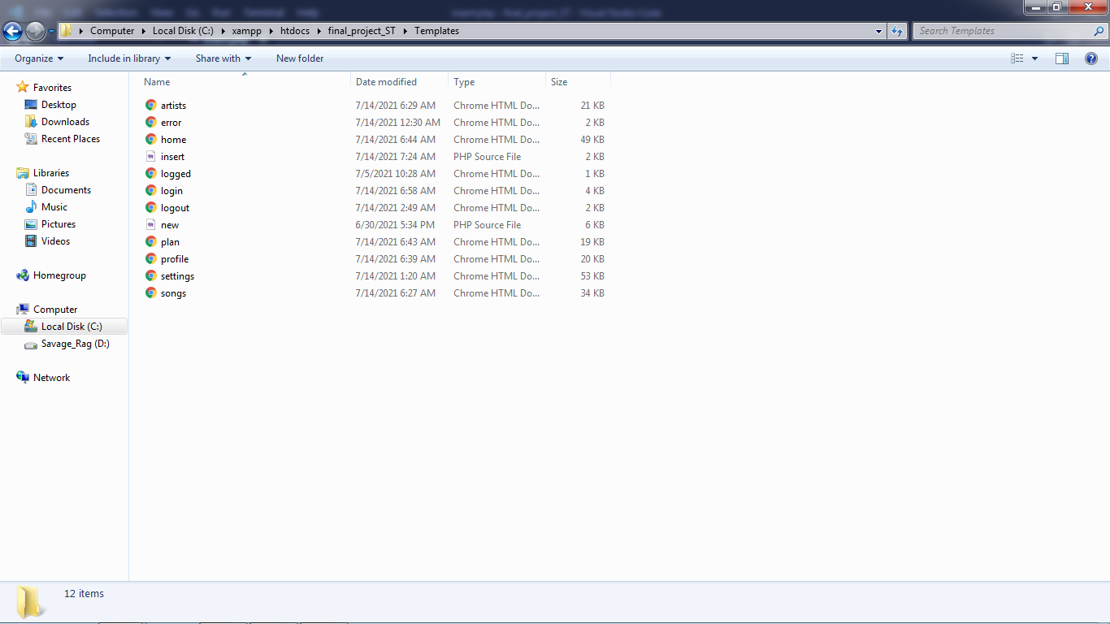

**List of css**

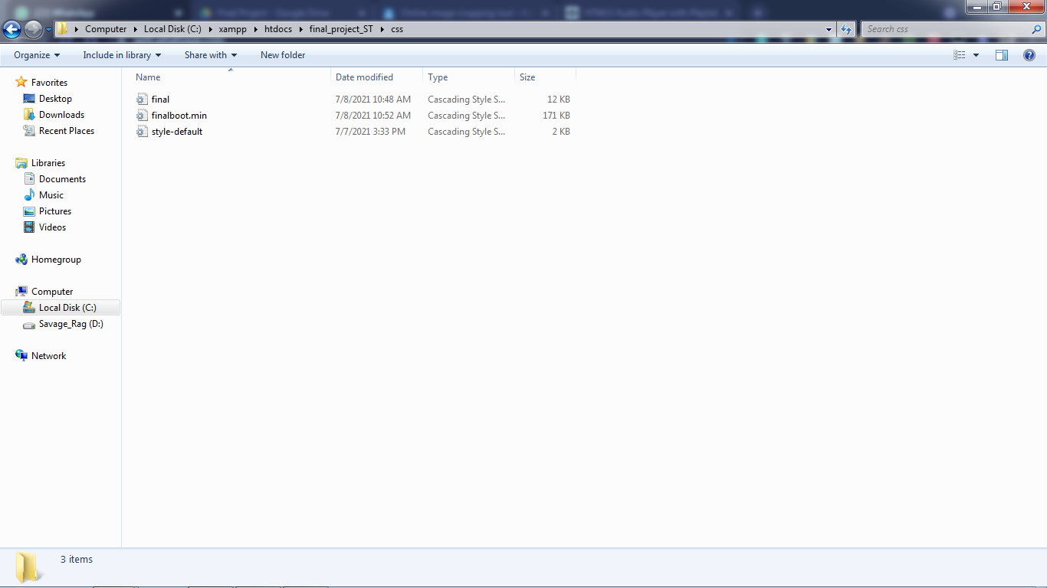

**List of Js Files**

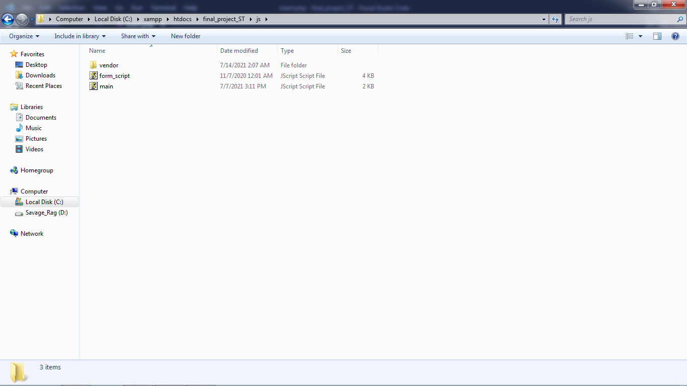

**CHAPTER 1 INTRODUCTION**

The website is aimed to be responsive made that can play music online with controls.

A music website should be professional, organized, yet show some creative flair. After all, if you are carving out a slice of the web just for your career, you want it to reflect your personality and your sound.

**What it offers:**

* Play music anytime
* It’s your choice to register or not!
* Collecting of user data
* Various songs and various artists
* Audio panel to control the music

Building a music website is the best solution for creating a centralized location where your fans can hear your songs and find out about your upcoming concerts and new releases. Musicians can also share photos, video and other media. It’s an important step to turn a hobby or idea into a real music career.

This site has different audiences who are looking for different things: fans who want to find out where you’re playing next, new listeners who are hearing you for the first time

**1.2 SOFTWARE REQUIRED**

* VsCode
* Xampp
* HTML
* CSS
* Javascript
* Bootstrap (Minimum)
* PHP
* Mysql



**Note:**

* VsCode can be replaced by any other editors in case, it’s not available.
* Must to have a mysql database to store the user info.

**1.3 XAMPP OVERVIEW**

XAMPP is the most popular PHP development environment

XAMPP is a completely free, easy to install Apache distribution containing MariaDB, PHP, and Perl. The XAMPP open source package has been set up to be incredibly easy to install and to use.

XAMPP has been around for more than 10 years – there is a huge community behind it. You can get involved by joining our Forums, adding yourself to the Mailing List, and liking us on Facebook, or following our exploits on Twitter.

MySQL was replaced with MariaDB on 19 October 2015 and beginning with XAMPP versions 5.5.30 and 5.6.14,[7] effectively altering the meaning of the acronym.

>> In this project, XAMPP is required to communicate with mysql and migrate the user entered data into database.



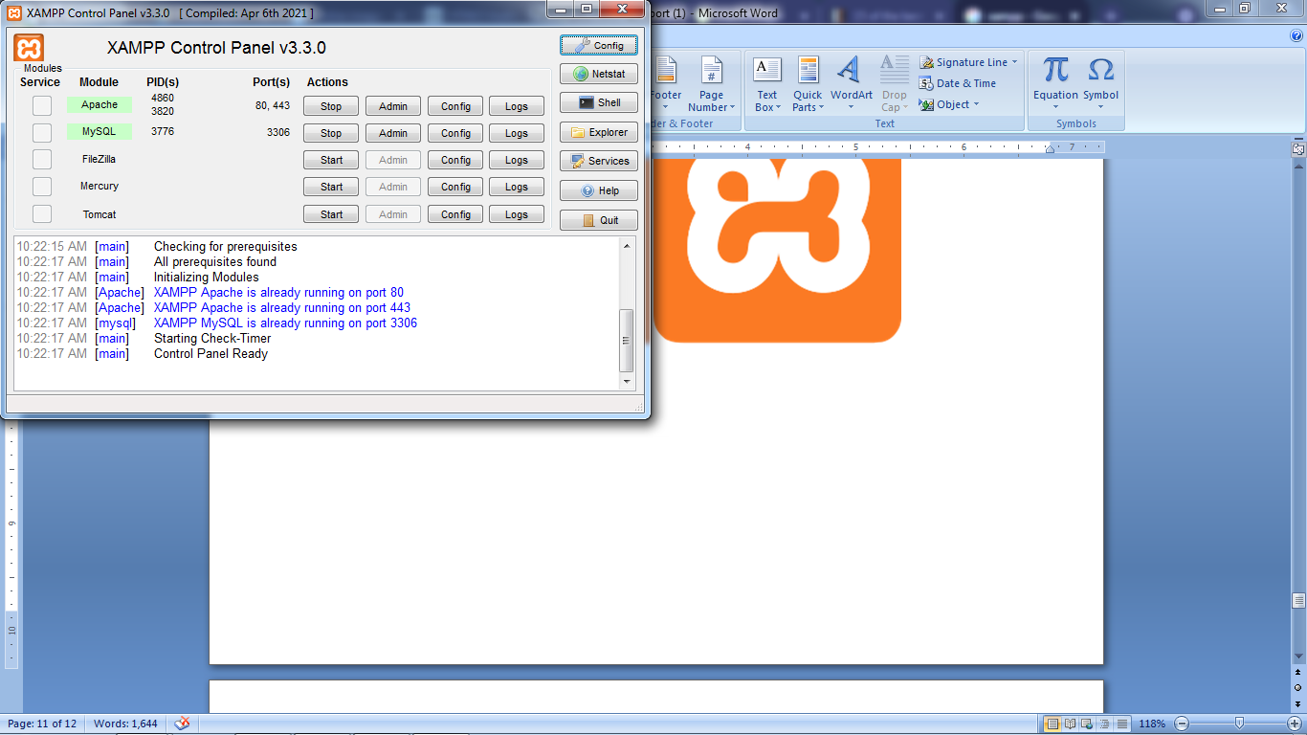

**1.4 DATABASE DASHBOARD (phpmyadmin)**

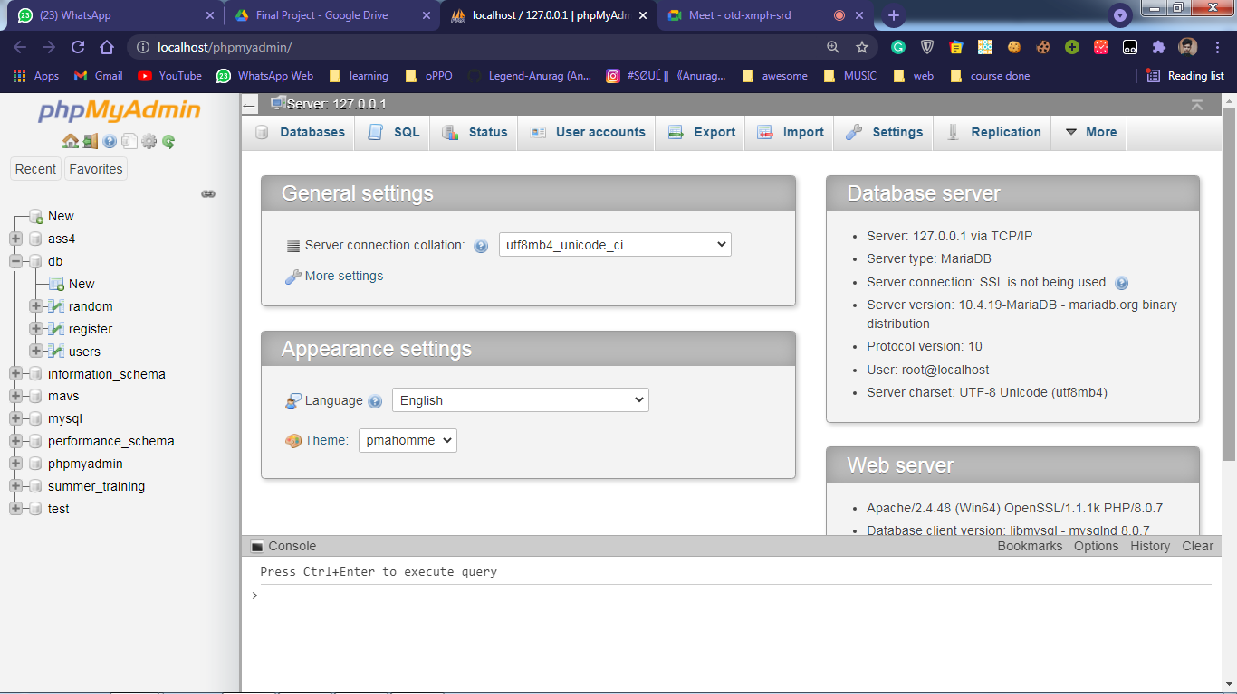

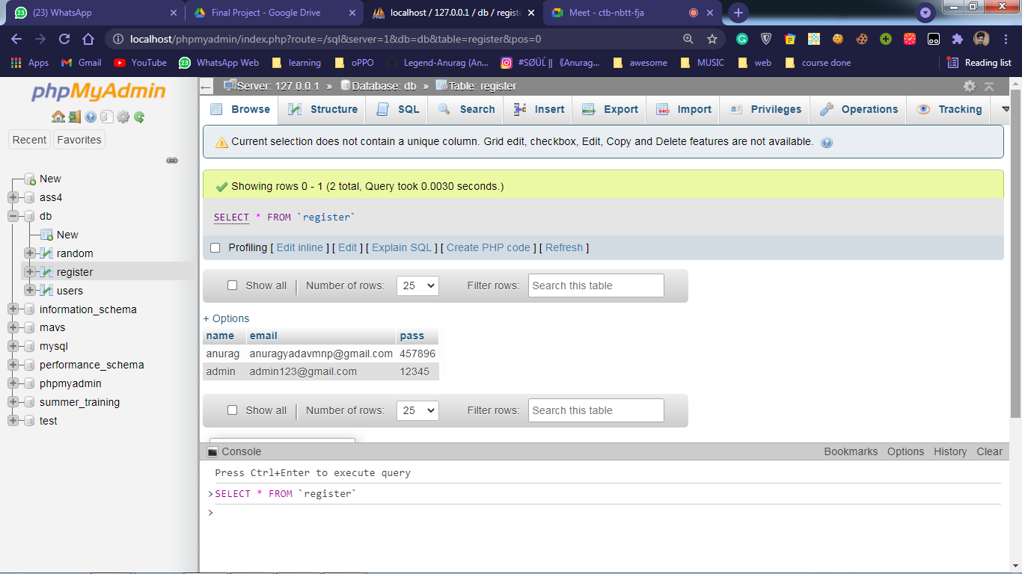

(The database ‘db’ used here is the one in which user’s data would get stored upon sign Up)

**CHAPTER 2 : WorkFlow of the Website**

The website comprises of five main webpages including:

* Landing Page
* Sign In/Up Page
* Main HomePage
* Music Stream (with audio controls)
* Log Out/Exit Page

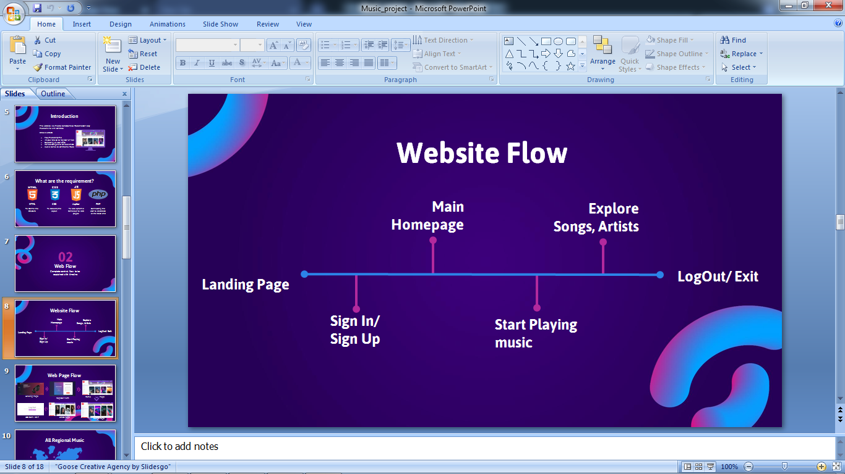

Let’s take a closer look on how the navigation and linking between these pages work. Also, the website offers some extra features too, will be briefed them later.

**2.1 Landing Page**

So far every website offers their specified landing page be it a product website, music website, grocery website and so on.

Keeping this in mind our website also comprises of a beautiful landing page (with a little bit of minimum bootstrap and obviously CSS). Have a look:

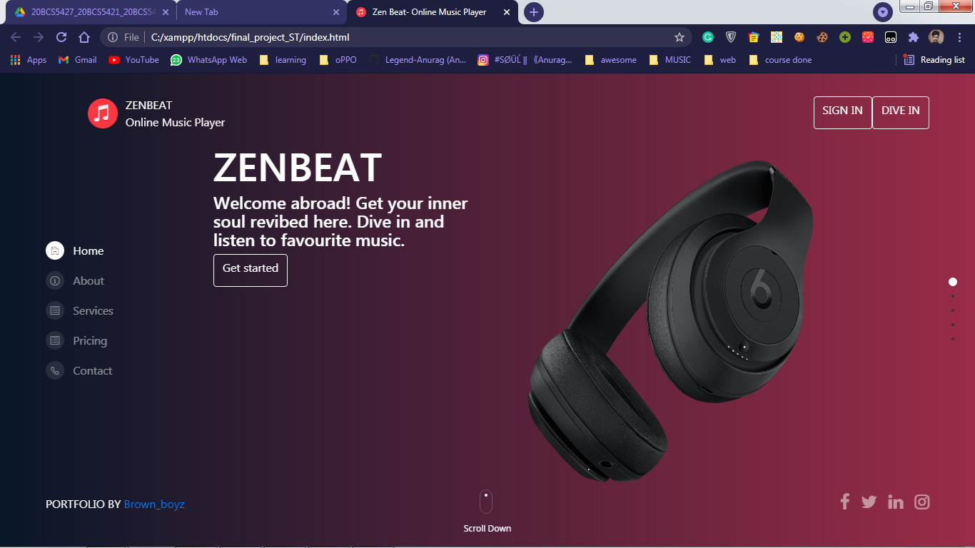

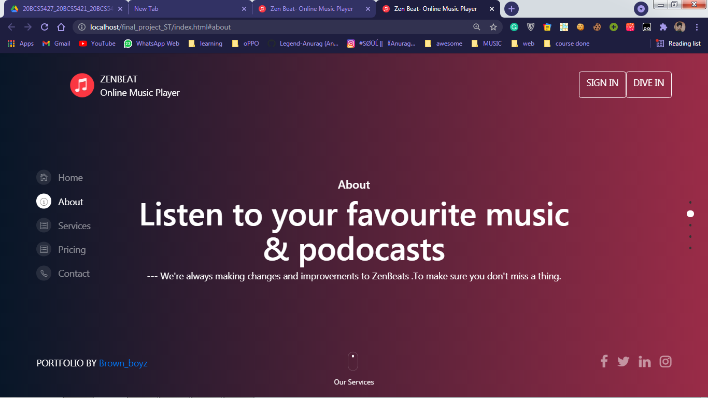

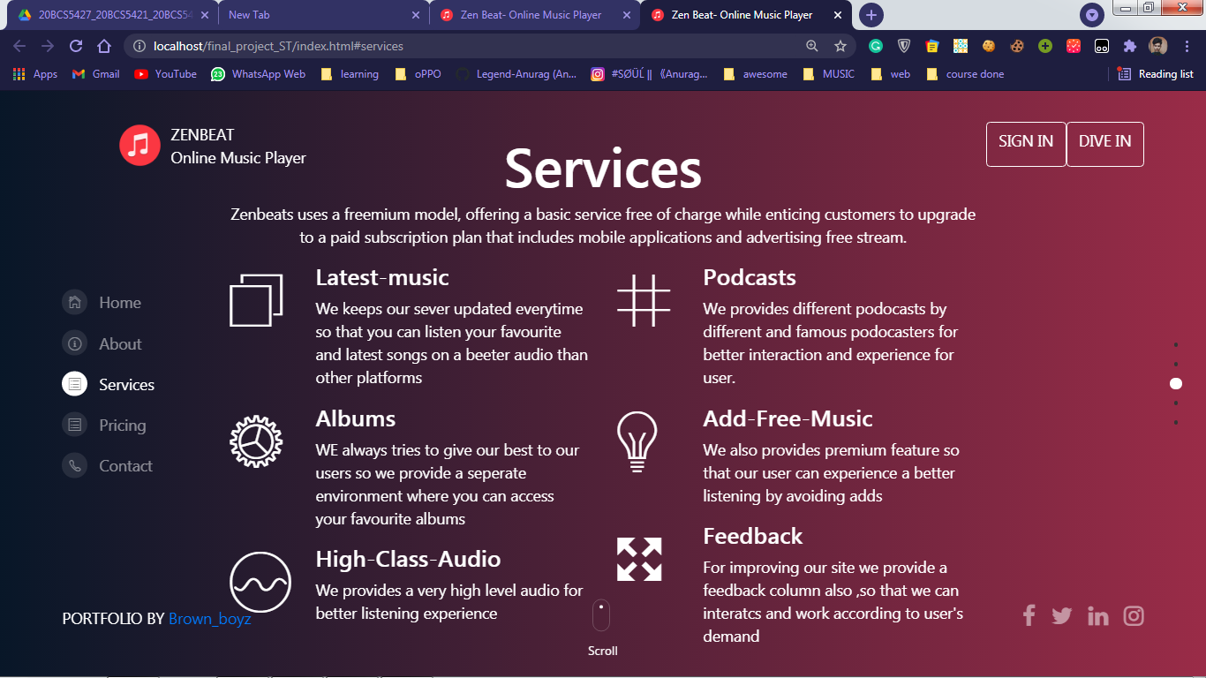

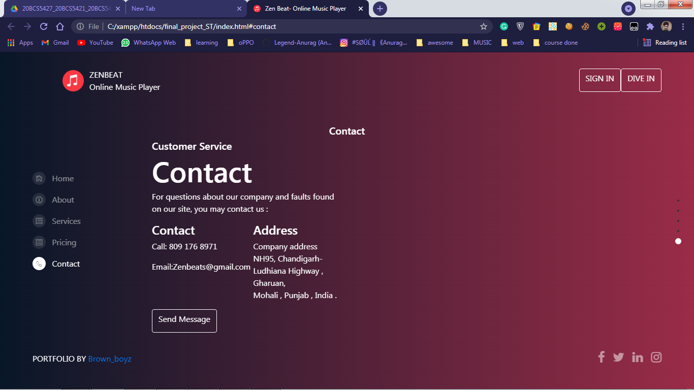

(Landing page includes a feedback form too.)

**2.2 Sign In/Up Page**

The must required page of a website is a user registration form. It enriches the website by interacting with user and get his details for future verification.

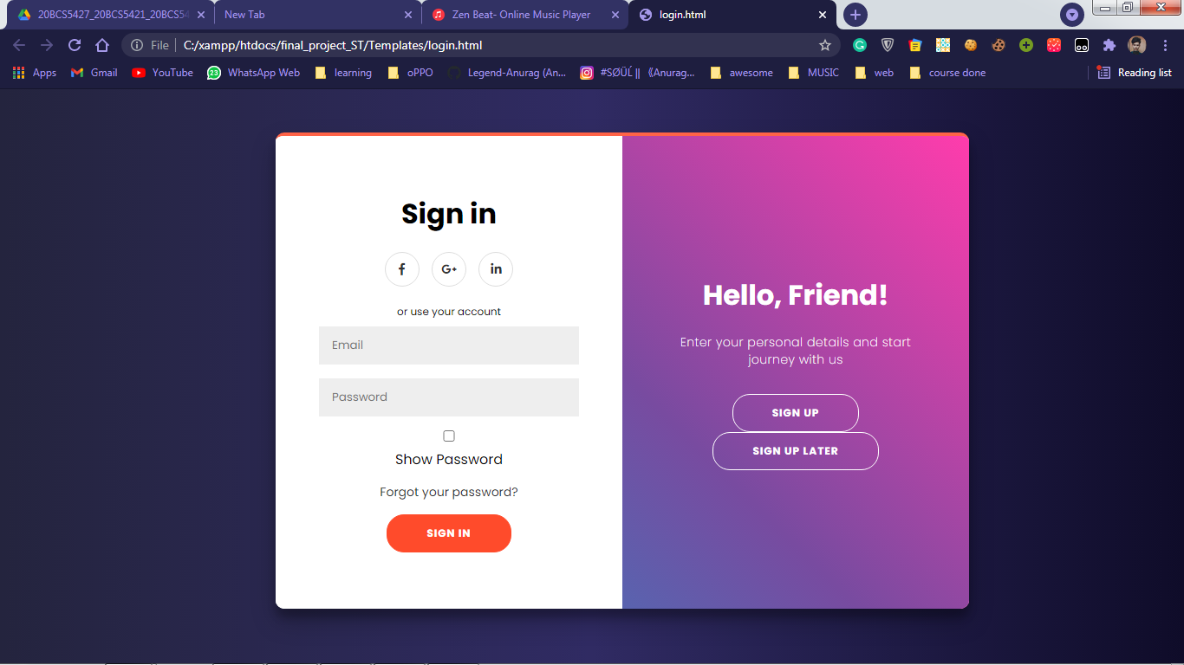

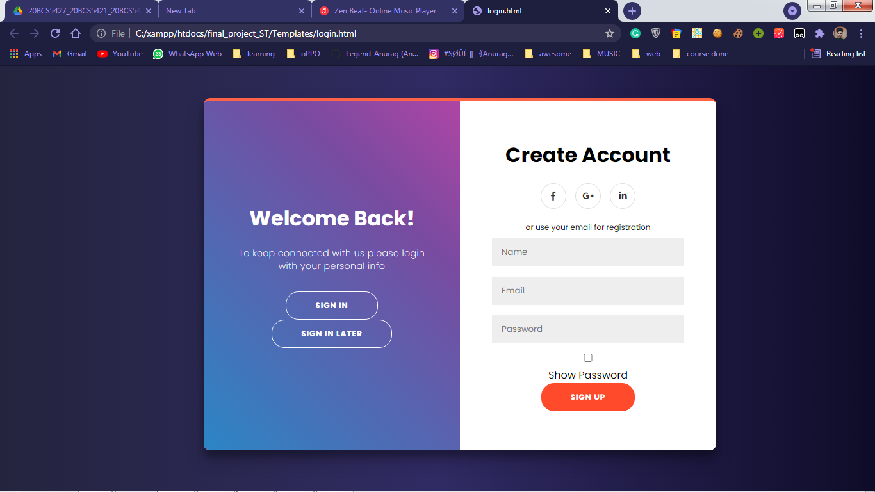

NOTE:

There are choices, you can select Sign In Later and it would take straight to homepage.

**2.3 Home Page**

After completing the registration form, the user will be redirected to homepage (or the main page) where user get to choose with many different songs to play with and enjoy the musical vibes.

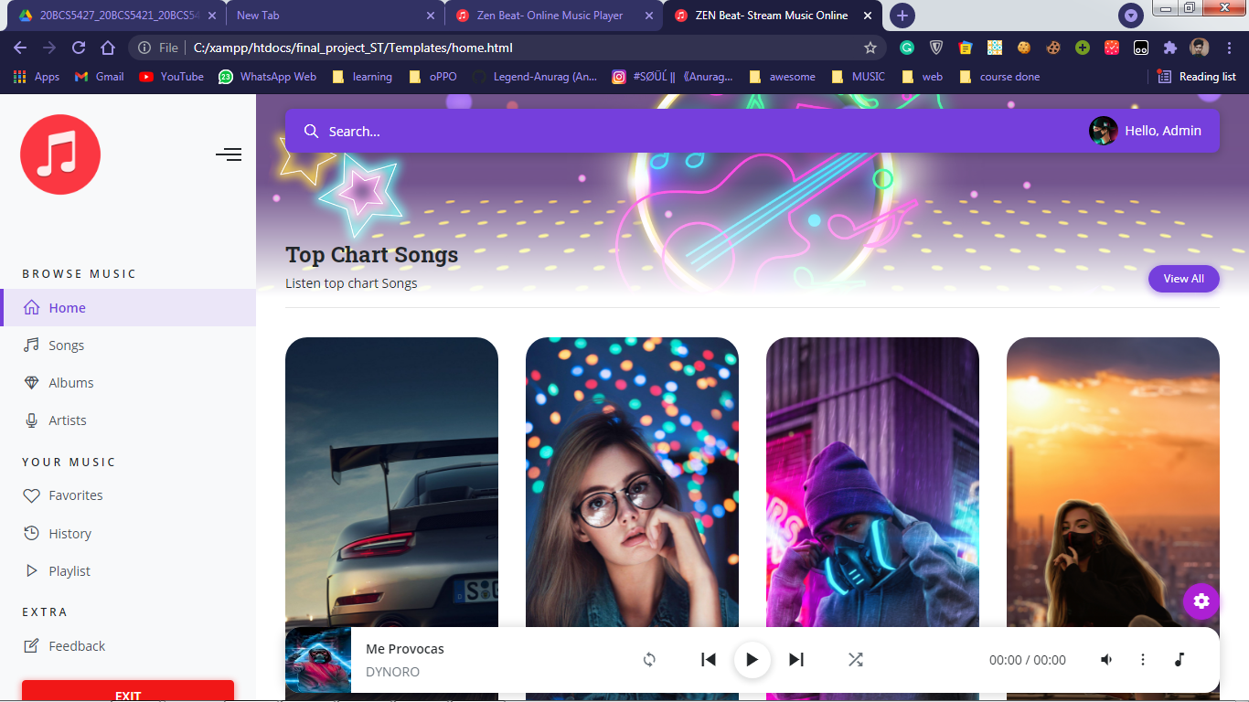

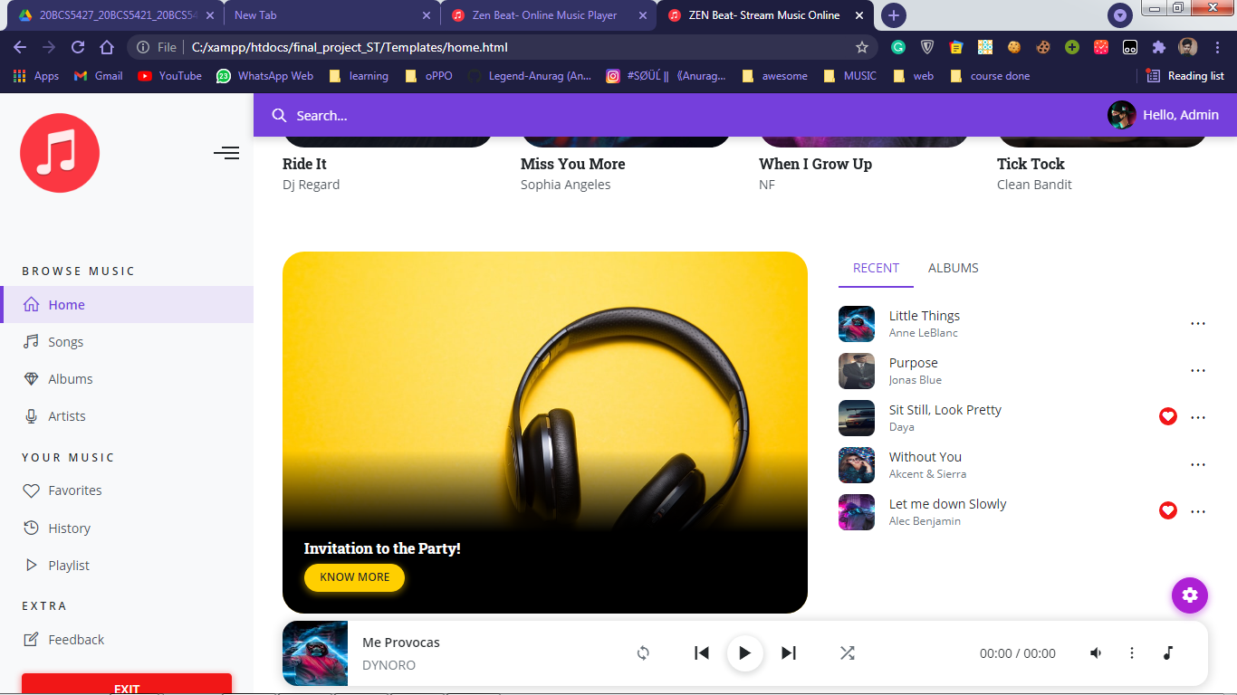

This is the homepage which display popular songs, popular artists and have sidenav bar which enables user to navigate through all sections.

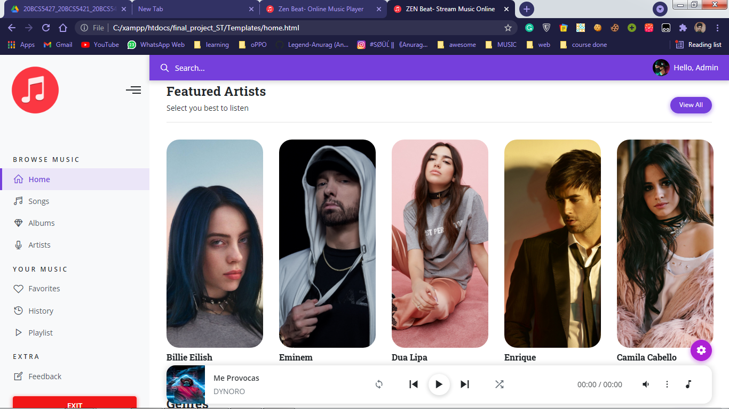

Also, side navigation provides a good look to homepage. By using this sidebar, we can navigate to different webpages to explore songs more.

Like if we select the ‘Songs’ option from side navigation bar, it will redirect the user to ‘songs.html’ webpage where the collection of songs lies. Take a look:

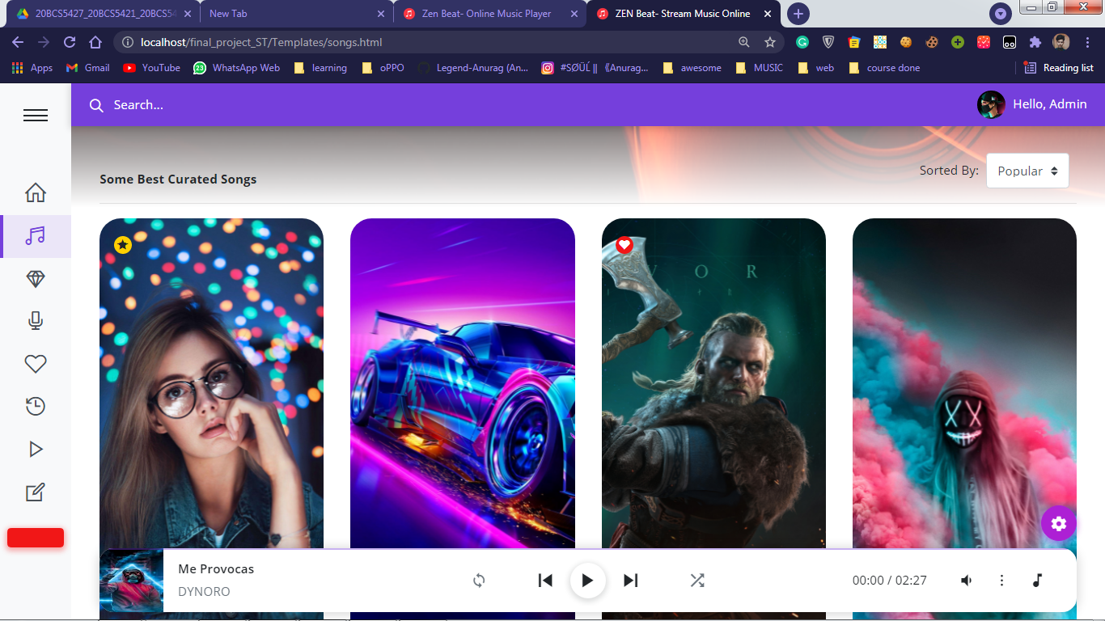

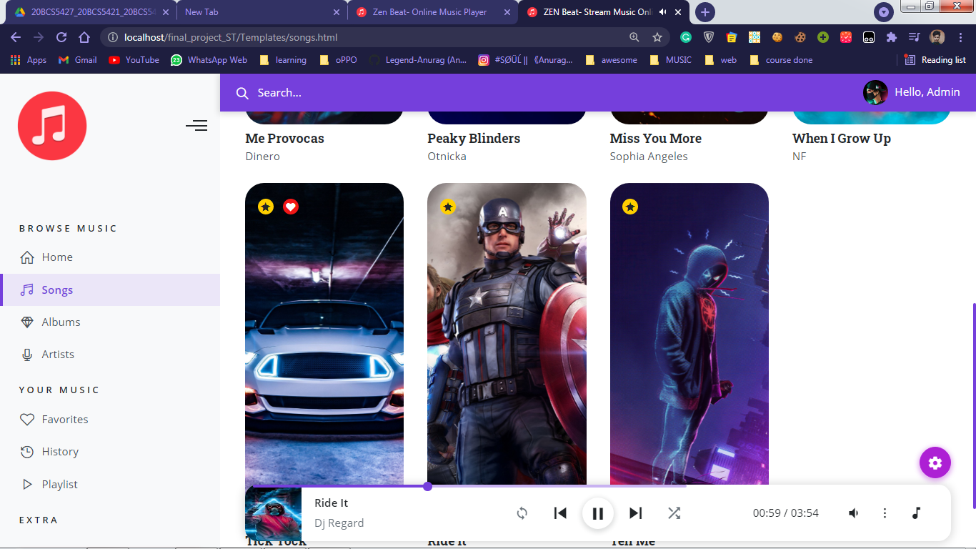

And if user choose to select ‘artists’ option from navigation bar, user will be redirected to “artists.htm” webpage comprising of all the list of artists as seen below:

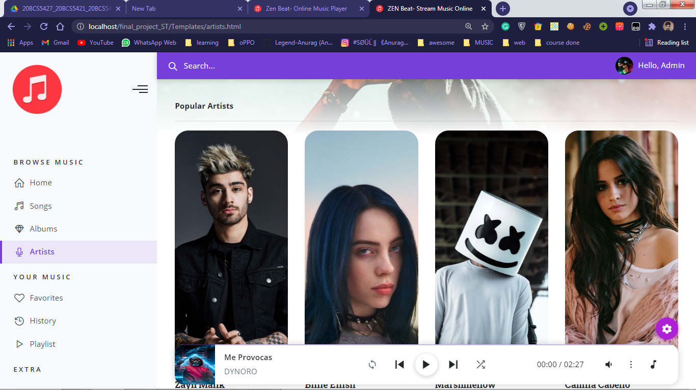

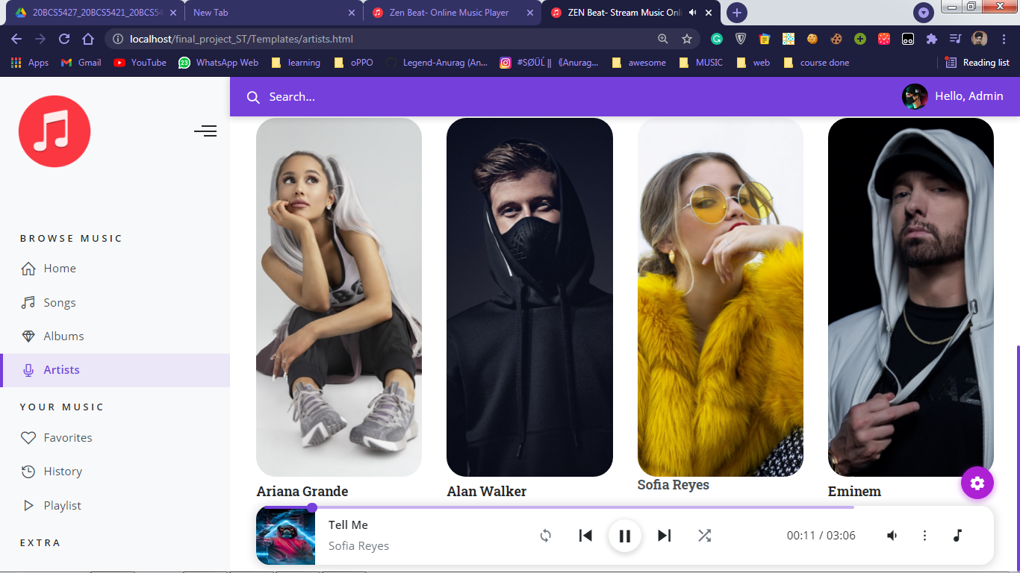

**2.4 Music Player**

The main element for a music website is to have an audio control layout. Here, we also used the same things. See the bottom**:**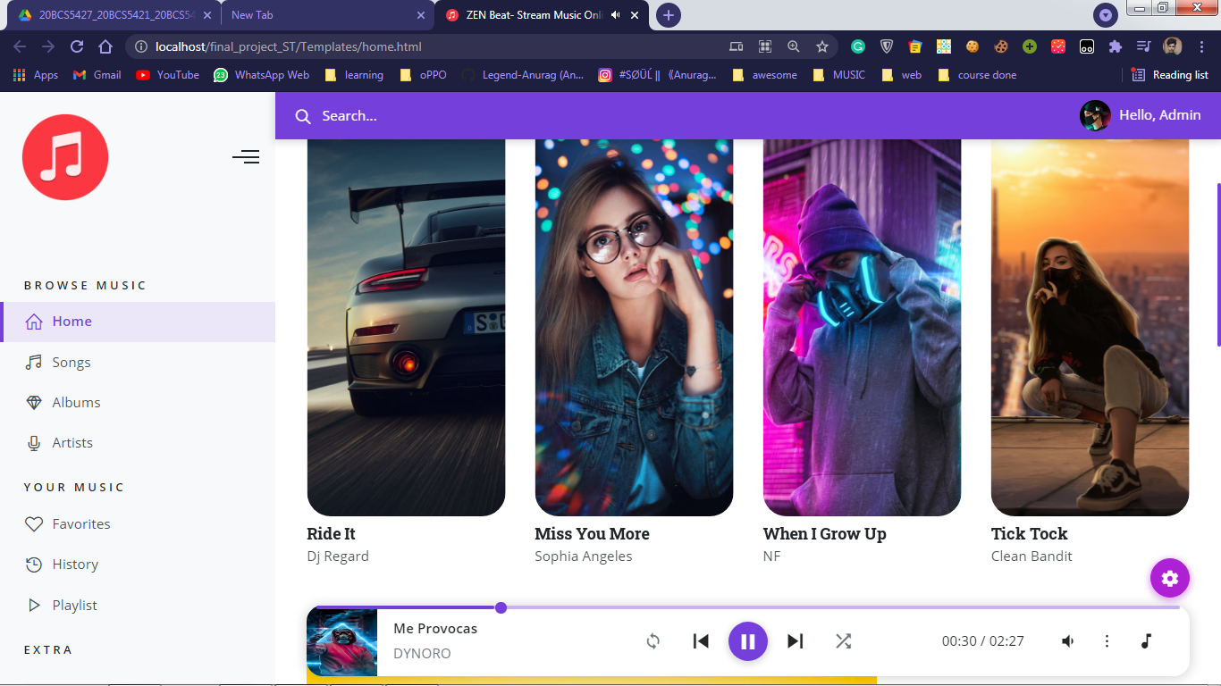

The audio player section on the bottom offers various options:

* Play/ Pause button
* Volume

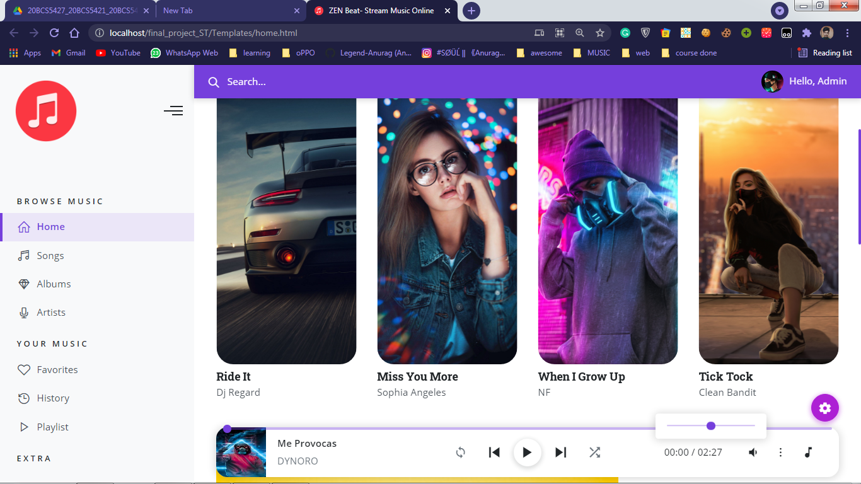

* Next/Previous
* Duration of Song
* More options

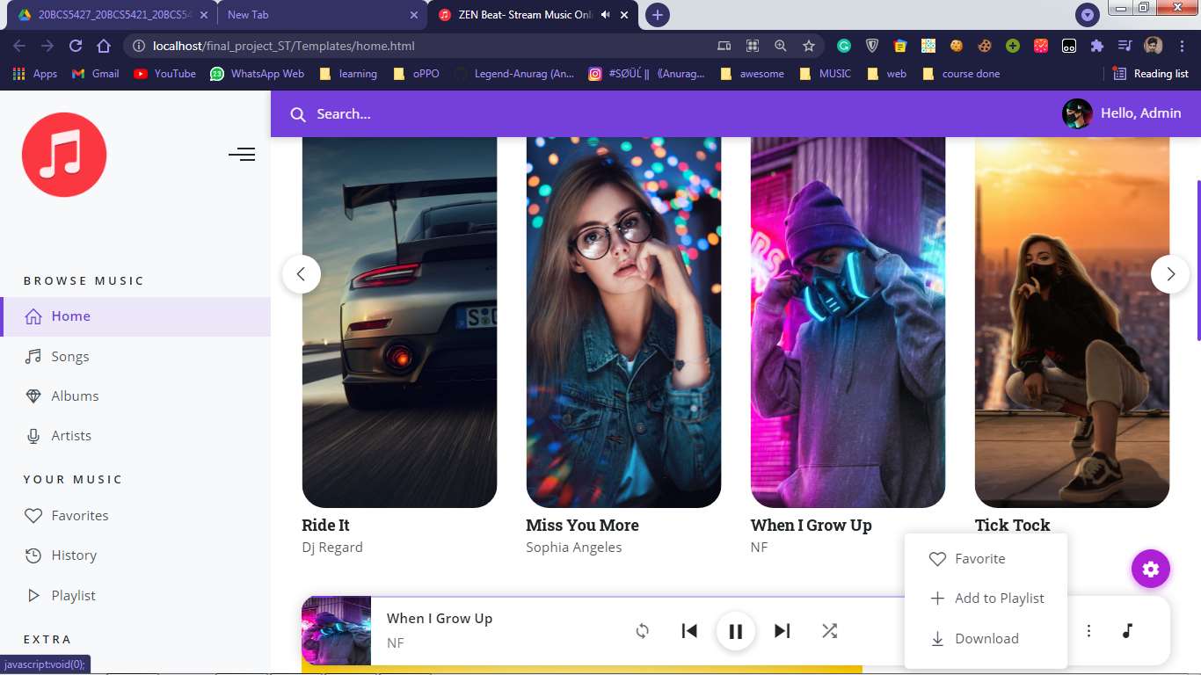

**2.5 Log Out/ Exit**

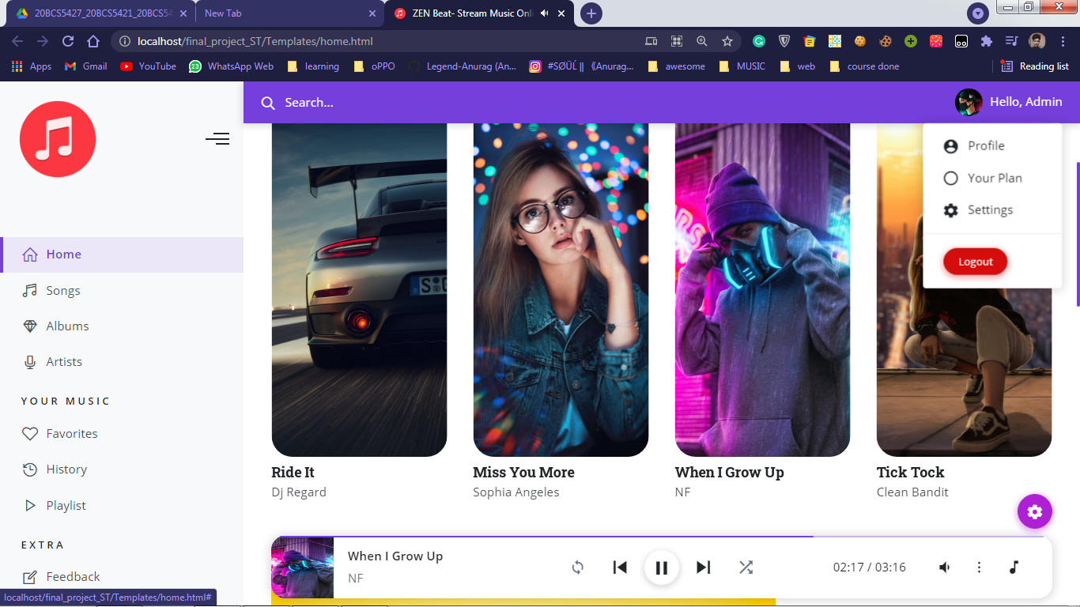

Upon selecting the Log Out option, the user will be taken to ‘logout.html’ webpage. If he/she wishes to go back, there are option to go back to homepage or landing page.

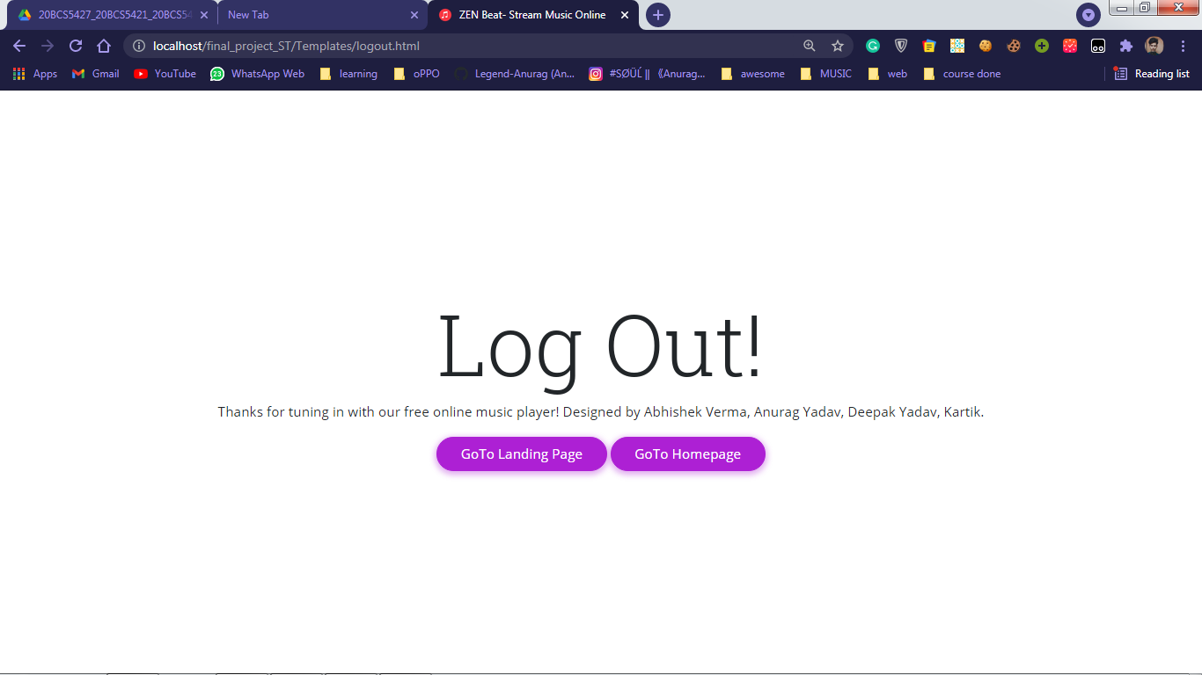

**2.5 BackEnd Connectivity**

**Requirements:**

* XAMPP
* Database (with table)
* Php code

**Code Required/ Used:**

<!DOCTYPE *html*>

<html>

<head>

    <title>Succesfull Sign Up</title>

</head>

<body>

    <center>

        <?php

*// database name => db*

        $conn = mysqli_connect("localhost", "root", "", "db");

*// Check connection*

        if($conn === false){

            die("ERROR: Could not connect. "

                . mysqli_connect_error());

        }

*//Taking all 3 values from the form data(input)*

        $user_name = $_REQUEST['username'];

        $user_email = $_REQUEST['useremail'];

        $user_pass = $_REQUEST['userpass'];

*//Performing insert query execution*

*//here our table name is register*

        $sql = "INSERT INTO register VALUES ('$user_name', '$user_email',

            $user_pass)";

        if(mysqli_query($conn, $sql)){

            header("Location: home.html");

            echo nl2br("\n$user_name\n $user_email\n "

                . "$user_pass");

        } else{

            echo "ERROR: Hush! Sorry $sql. "

                . mysqli_error($conn);

        }

*//lose connection*

        mysqli_close($conn);

        ?>

    </center>

</body>

</html>

As stated above, the database used here is ‘db’ and the table is ‘register’ we are using input tag to get the user data from a form having method ‘POST’:

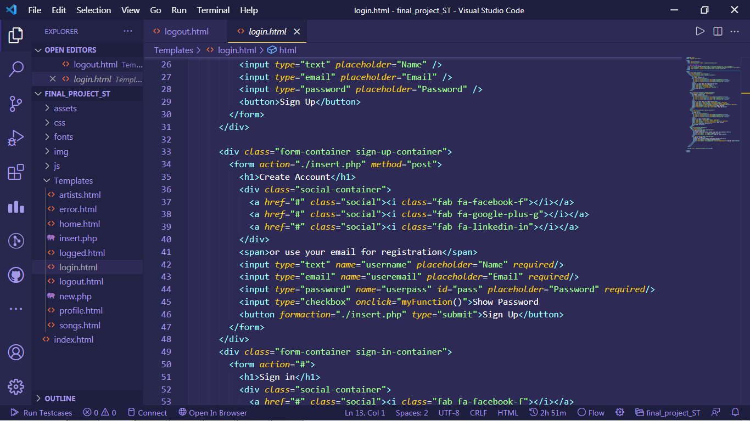

**Code/Execution**

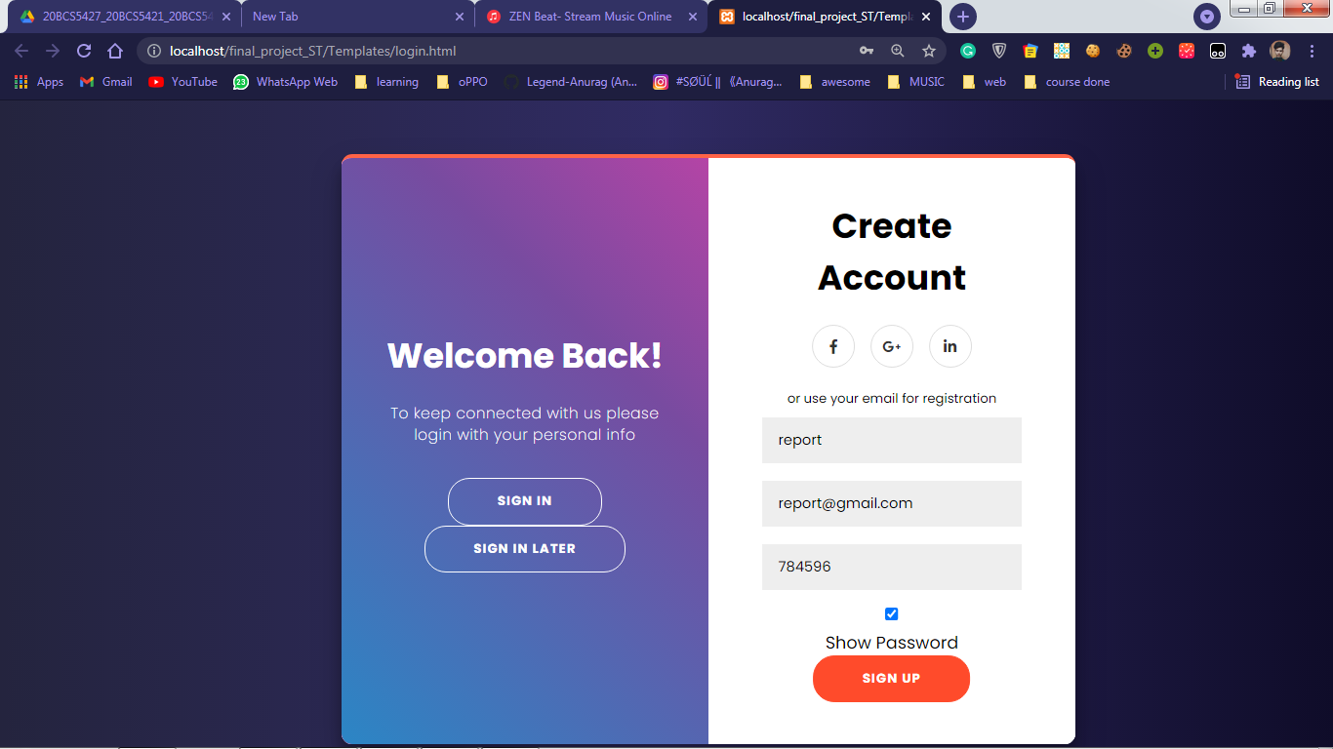

On the sign in/up page, enter the required data. And if the data entered by user is proper, the homepage of the website would load up.

And the data entered by user would be save into the mysql database. See Below screenshot:

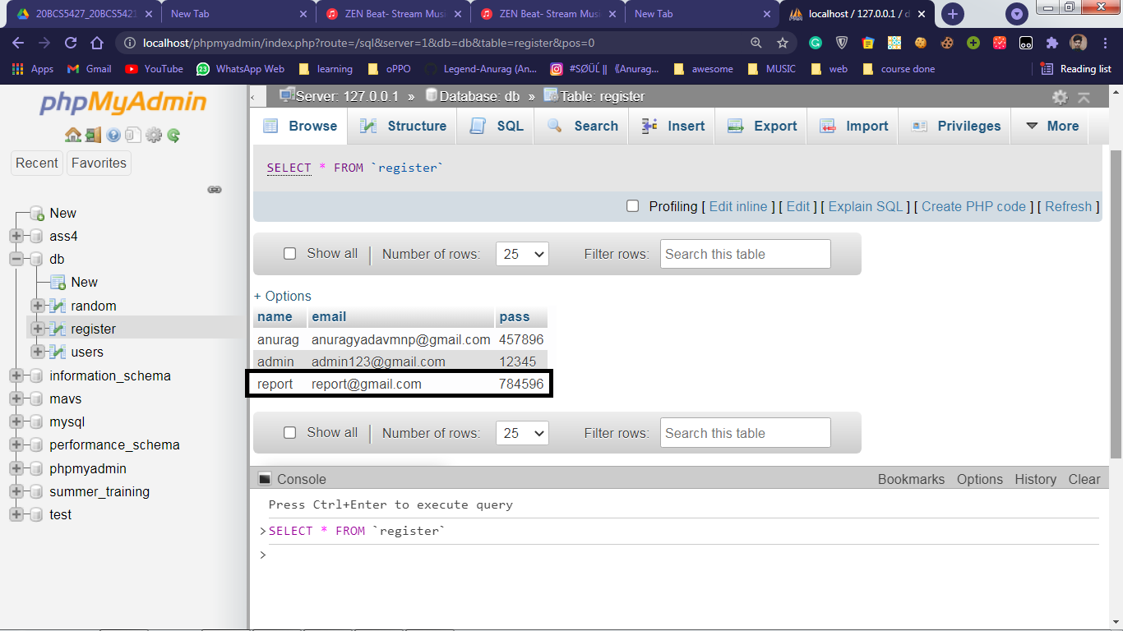

Hence, Verified that the data entered by user is being migrated to the mysql database using php connection with the help of form POST method.

**3.1 My Contribution**

**I have created a landing page in this project.**

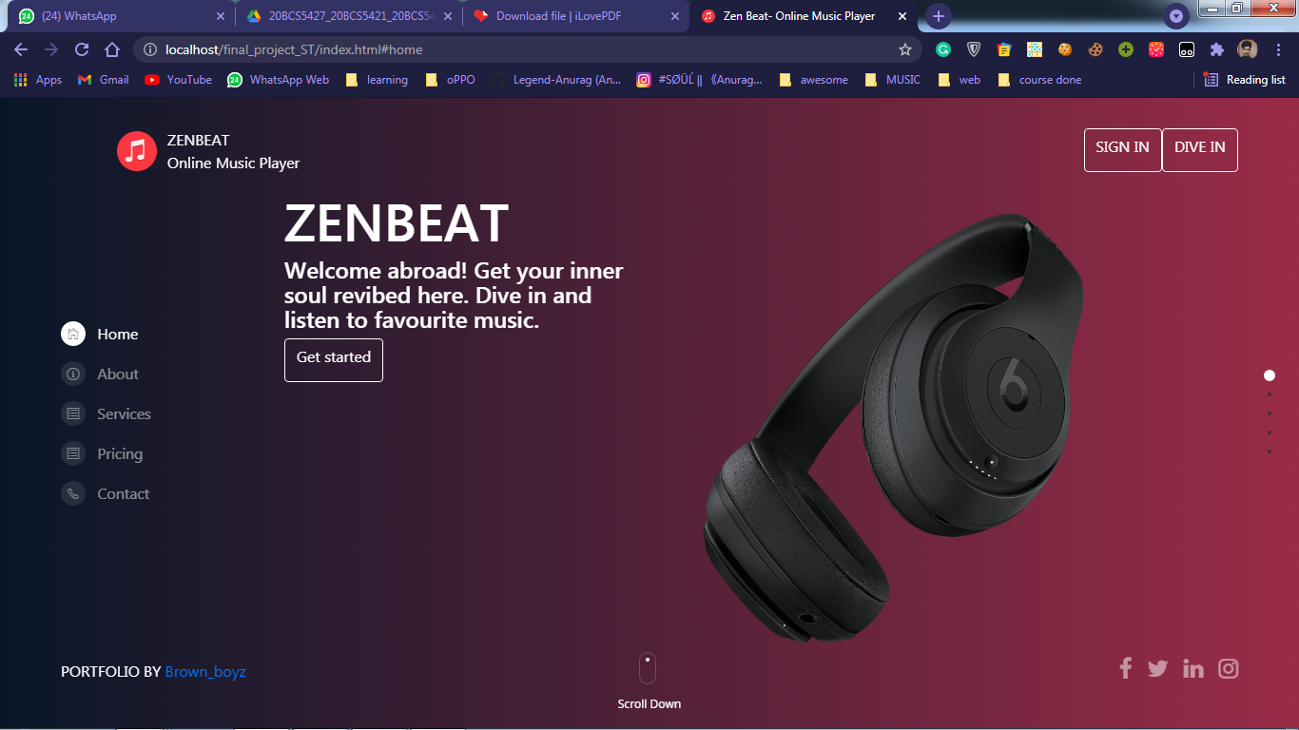

In this page, we have given the navigation bar at the top in which the button of " Dive In " this is given in the right side corner. We have to click on this button to go to the home page. And "Sign In" button is given on the left side of the Dive In button.In the left-side middle of this page, there is a navigation menu, where we have given 5 buttons which are of Home, About, Services, Pricing and Contact.By clicking on all these buttons, we can go to different pages.

**3.2 Future Scope**

**Features that can be added further:**

**Events:**

Organize events to connect with artists and fill the gap between music lovers and music makers.

A live global counter showing the total number of tracks listened to by our users

**Check around the world:**

Regional music with a vibrant choice to choose from, What's being listened to right now and where? How popular is that track across the globe?

**Genres:**

Whether you’re behind the wheel, working out, partying or relaxing, the right music or podcast is always at your fingertips. Choose what you want to listen to

Want to hear some 80s Electronic? How about some millennial Metal?

**Language Selection:**

Since people belonging to different cultures, different regions, how about the language selection option attract users from over all the globe and make them glad.

**Online Sources / References**

**WWW**

[1] CSS Gradients : <https://uigradients.com/#BacktotheFuture>

[2] Sidebar Setup : <https://www.codinglabweb.com/2021/04/responsive-side-navigation-bar-in-html.html>

[3] Bootstrap : <https://getbootstrap.com/>

[4] Social Icons Template : <https://codepen.io/zFunx/pen/YEvmvB>

[5] Animate Text Sample : <https://codepen.io/hudsontay/details/WpWLwp>

[6] Crop Image : <https://www.img2go.com/crop-image>

[7] Images : <https://unsplash.com/s/photos/iphone-wallpapers-hd>

[8] Audio Controls : <https://codepen.io/craigstroman/pen/aOyRYx>

**Tutorials:**

[1] Channel reference : <https://www.youtube.com/c/OnlineTutorials4Designers/videos>